Activity Sheet 1.3: Expense Cheat Sheet

Below are some average costs for living expenses in Quebec. These will fluctuate based on where you live.

Average Monthly costs

One-bedroom rental: $600-$800

Two-bedroom rental: $800-$1,600

Groceries: $200-$250 per person

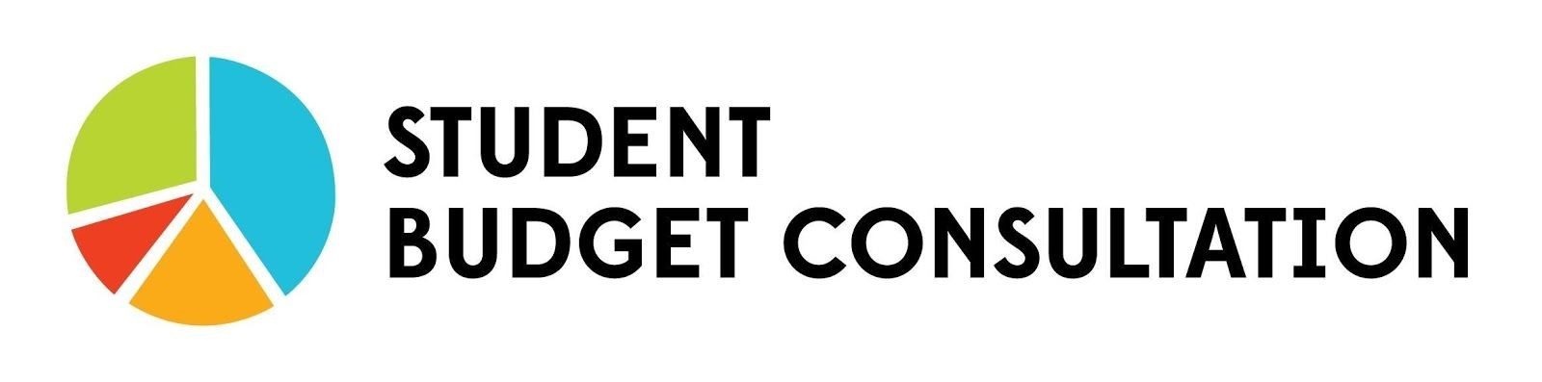
Household communications (phone, cable and Internet): $200-$250

Car costs (maintenance, gas, insurance): $450

Utilities (gas/heating, electricity): $175

Daycare: $170-$400

Other Costs

Wedding: $300 (Civil)— $20,000 (reception)

Condo/House: $200,000-$400,000 (Canadian average: $250,000)

University: $3,330 per year

CEGEP: $800 per year (for 2 sessions including books and materials)

